***Group Members: (Anees Ahmed,Sp20-Bse-053), (Abdullah Khan,Sp20-bse-042), (Shahmeer Mukhtar,sp20-bse-076), (Huzaifa Shad,sp20-bse-054), (Munawar Jamil,Sp20-bse-056), (Sadaqat Hussain,sp20-bse-058)***

***Group leader: Anees Ahmed***

***Project Name: E-Commerce***

***Use Case Diagram:***

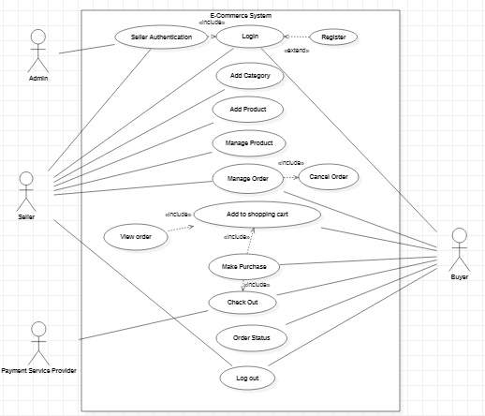

***Domain Diagram:***

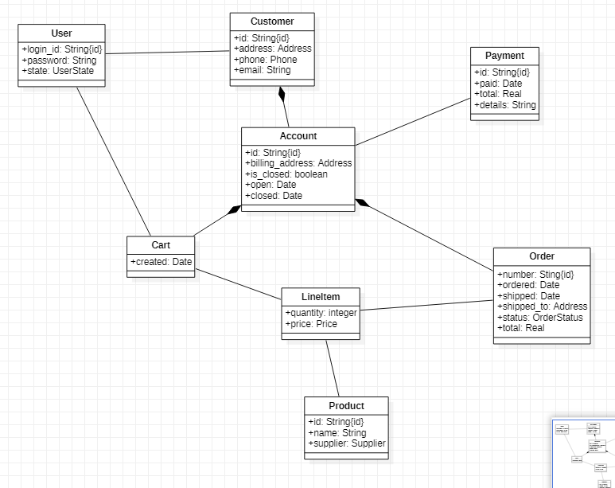

* ***Anees Work:***

***Use case Description:***

After selecting product buyer will select available payment options like easypaisa, jazzcash, bank account and if they don’t have account in any of them he will pay on delivery. Also buyer must have cash in account. He can pay multiple orders payment at one time by just adding orders and payment will also be added and buyer will pay against all orders. If buyer pay successfully he will receive message.

***Use case diagram:***

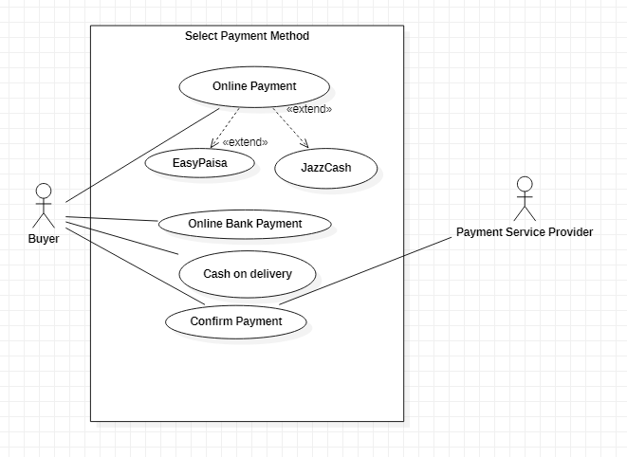

***Fully Dresses Use case:***

|  |  |
| --- | --- |
| **Name** | Select Payment Method |
| **Scope** | We will add payments methods if some new method come into market |
| **Level** | Our goal is to provide all available online payment methods and sub functions are easypaisa or jazzcash |
| **Primary Actor** | Buyer. |
| **Stakeholder and Interests** | 1. Seller: Who wants to sell the product 2. Buyer: Who wants to but the product 3. TCS: who get delivery charges |
| **Preconditions** | Every user must have an account in application. User must fulfill payment methods and also have online account. |
| **Postconditions** | User receive message that payment is selected successfully |
| **Main success scenario** | User provide correct account information in online payment method |
| **Extensions** | Accounts details should be valid |
| **Special requirements** | * Provide security (online payment method should be authentic, user can trust on it). |
| **Frequency of Occurrence** | Every time user place order, Select payment against orders. |

***SSD Diagram:***

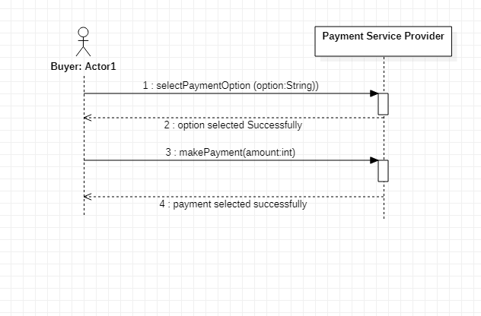

***Operational Contract:***

|  |  |
| --- | --- |
| **Operation** | selectPaymentOption(option:String) |
| **Cross Reference** | Select Payment Method |
| **Pre-Condition** | User should have account in available online payment methods |
| **Post-Condition** | Buyer should go to login page to enter his account details(email,password etc) to pay the amount in entered option. |

|  |  |
| --- | --- |
| **Operation** | makePayment(amount:int) |
| **Cross Reference** | Select Payment Method |
| **Pre-Condition** | Buyer must have balance in account. |
| **Post-Condition** | After confirming payment user must receive message that he does payment successfully. |

* ***Abdullah work:***

**Fully dressed Use Case**

|  |  |
| --- | --- |
| **Name** | Sign up |
| **Level** | If user forgets password, they will user forget password feature to enter new password |
| **Primary Actor** | Buyer and seller |
| **Stakeholder and Interests** | 1. Seller: Who wants to sell the product 2. Buyer: Who wants to but the product |
| **Preconditions** | 1. Buyer: User selects the buyer account for buying products 2. Seller: User selects the seller account for selling products |
| **Postconditions** | Verification email is sent after checking the format of email |
| **Main success scenario** | 1. Verification is completed 2. After verification of email account is created 3. User is logged in the account |
| **Extensions** | If user enter short password or invalid email address; error will be displayed |
| **Special requirements** | Valid Email address  Valid username |
| **Frequency of Occurrence** | Every time a new user wants to login they will have to create new account |

|  |  |
| --- | --- |
| **Name** | Login |
| **Level** | If user forgets password, they will user forget password feature to enter new password |
| **Primary Actor** | Buyer and seller |
| **Stakeholder and Interests** | Seller: Who wants to sell the product  Buyer: Who wants to but the product |
| **Preconditions** | User must have a valid account  Device must be connected to internet |
| **Postconditions** | User is successfully logged in |
| **Main success scenario** | If email is valid and password is correct user will be logged into account |
| **Extensions** | If user enter wrong password or invalid email address; error message will be displayed |
| **Special requirements** | Valid Email address  Valid password |
| **Frequency of Occurrence** | Every time a user wants to create an account for buying or selling |

**Use case Description**

**Login**

The System prompts the user for a username and password or register new account. The user enters his/her username and password. The system validates the entered username and password, making sure that the entered username is a valid username in the System, and that the required password is entered for the entered username. The user is signed in and returned to the home page as a Logged In User and the use case ends.

**Sign Up**

The system prompts the user to select a buyer or a seller account. After selecting the type of account, the System request the user for a username and password or register new account. The user selects registration option. The System prompts user for registration information, Username, password, etc*.* The user enters in their information. System verifies information and creates account and the use case ends.

**SSD**

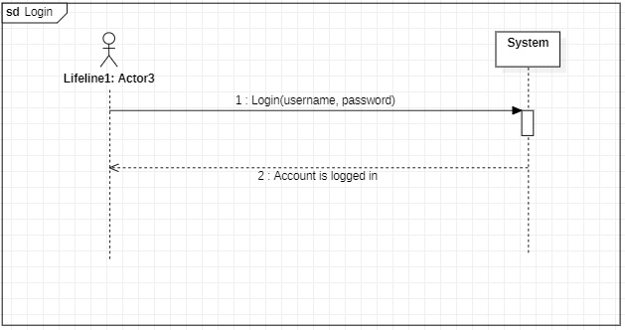

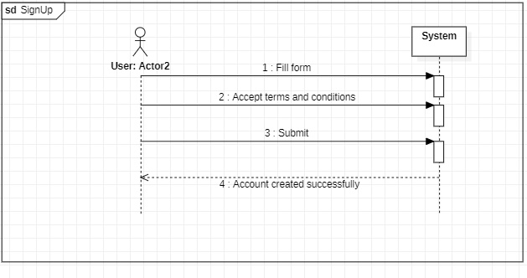

**Operation Contract**

**Operation Contract: Login**

|  |  |
| --- | --- |
| **Operation** | User has to enter username and password and checked if it is a valid user account and is logged in |
| **Cross Reference** | LOGIN |
| **Pre-Condition** | Enter information in text fields |
| **Post-Condition** | Logged In |

**Operation Contract: Sign Up**

|  |  |
| --- | --- |
| **Operation** | User has to enter username, password and email address for the creation of account |
| **Cross Reference** | SIGNUP |
| **Pre-Condition** | Enter information in text fields |
| **Post-Condition** | Email is verified by checking format of email and is sent a verification code and the account is created |

* **Shahmeer Work:**

**Fully dressed Use Case**

|  |  |
| --- | --- |
| **Name** | Place Order |
| **Scope** | Buyer login with buyer account and order products. |
| **Level** | Order goal is user can order his/her selected item. |
| **Primary Actor** | Buyer and seller |
| **Stakeholder and Interests** | 1. Seller: Who wants to sell the product 2. Buyer: Who wants to but the product |
| **Preconditions** | 1. Buyer: User select item which he/she want to order 2. Seller: : User upload item which he/she want to order |
| **Postconditions** | Confirm order after getting valid Email, Address and Phone No. |
| **Main success scenario** | Buyer: Place Order Successfully after providing the various details.  Seller: Successfully upload products after giving proper description about product. |
| **Extensions** | Condition:   1. Email must be valid. 2. Description must be proper. 3. Valid Phone No. must be provided. |
| **Special requirements** | Valid Email address  Valid Phone Number |
| **Frequency of Occurrence** | Anytime User can place order and Seller can upload products. |

**Place Order:**

Buyer give his/her proper Email , Address and Phone No. to confirm the order of his/her selected product. Order will confirm after send buyer a verification code to confirm buyer phone No. after that he make payment for his order to get a receipt of order. Receipt consist of Buyer order details. On the other hand, Seller upload products which he/she wants to sale. Seller must gives a description about his/her product.

**OPERATION CONTACT: PLACE ORDER**

|  |  |
| --- | --- |
| Operations | Buyer login from buyer account then search product and place order |
| Cross reference | Place order |
| Pre-condition | Buyer select item which he order |
| Post-condition | Order placed |

**System Sequence Diagram:**

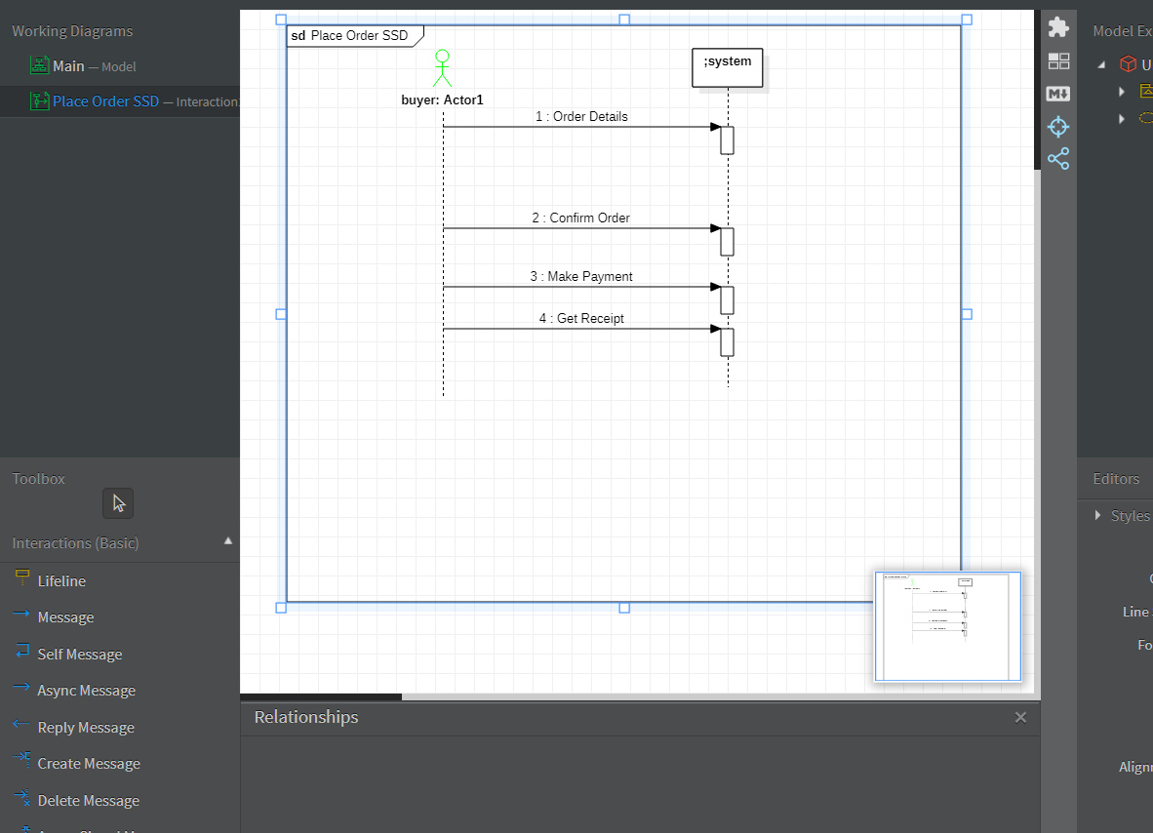

* **Sadaqat Work:**

**Use cases of search items**

**Use case diagram:**

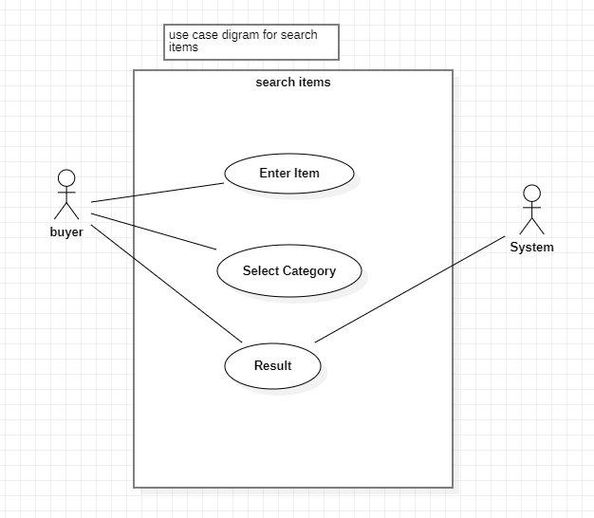

**Fully dressed use case:**

|  |  |
| --- | --- |
| **Name** | Search Item |
| **Scope** | We will modify functionalities when new functionality come into market. |
| **Level** | Items will be displayed when entered keyword is correct. |
| **Primary Actor** | Buyer |
| **Stakeholder and Interests** | Buyer, seller, system |
| **Preconditions** | Entered keywords must be valid |
| **Post conditions** | If keyword is valid items will be displayed |
| **Main success scenario** | Results will be displayed against entered keywords |
| **Extensions** | Entered keywords should be valid than item show |
| **Special requirements** | System must respond in short time |
| **Frequency of Occurrence** | Every time user wants to buy something |
|  |  |

**SSD diagram:**

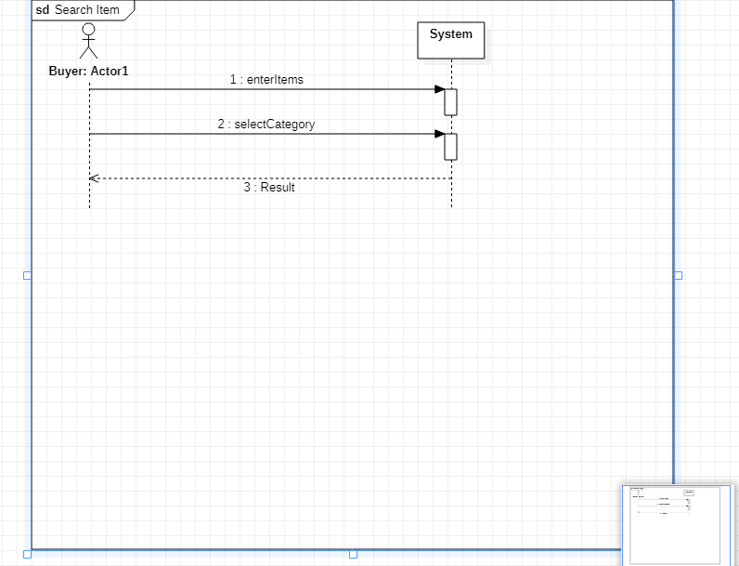

**Operational Contract:**

|  |  |
| --- | --- |
| **Operation** | User has to enter keywords of the required product or choose from category fields to search for desired items |
| **Cross Reference** | Search item |
| **Pre-Condition** | Keywords must be valid |
| **Post-Condition** | Items will be displayed against keywords |

**Select Category:**

|  |  |
| --- | --- |
| **Pre-Condition** | Category should be selected |
| **Post-Condition** | Items will be displayed when category will selected |
|  |  |
|  |  |

**DESCRIPTION**:

Seller will login to his/her seller account than he/she will go to the product category and will search for new product his/her job is to find the products the user is looking for by matching the user's search keywords with the products in your store. When customers use slang words to describe products and abbreviations or symbols in search.

Seller its over choice to choose different product checking quality .and it is very easy to search items checking quality .easy to dealing.

* ***Huzaifa Work:***

**Add products:**

**SUMMARY**

You can add or update information about a product such as its price, variants, and availability from the Products page in your admin.

If you want to save specialized information or files for your products, then you can add custom fields to your product pages by using metafields. .On this page

**Add a new product**

**Edit a product**

**Make products available to your sales channels**

**Scan a barcode with your device's camera**

**Archive a product**

**Delete a product**

**Add a new product**

**see sale products**

other product details.

Although you can change your product details at any time, the changes can affect your reports. For information on how the changes can affect the way that products appear and are grouped in your reports, see Changes to product details.

Saved changes take effect immediately in your online store. Before you update a product, you can check the top of the page to see if another staff might also be making changes to the same product.

**SSD:**

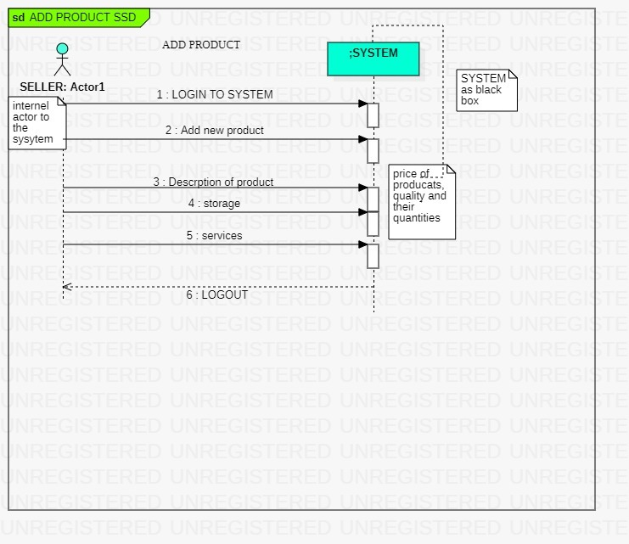

**Operation contract:**

|  |  |
| --- | --- |
| Operations | Seller Enters into seller account and check it is seller account. Then ADDING their products in product inventery |
| Cross Reference | Add Product |
| Pre-Condition | Information about seller and product details then adding product |
| Post-Condition | product added |

**USE CASE OF ADD PRODUCT:**

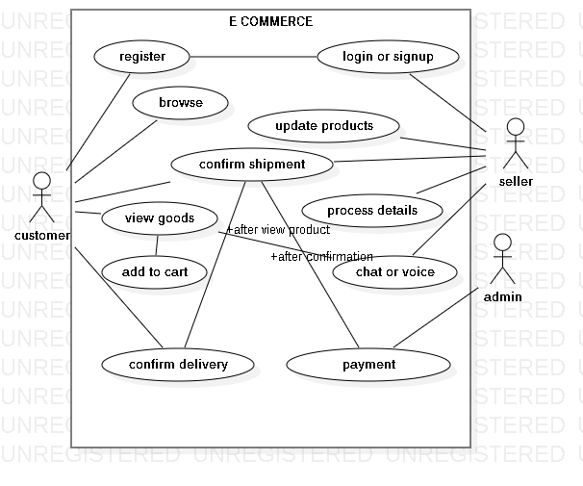

**DOMAIN MODEL DIAGRAM OF ADD PRODUCT USE CASE**

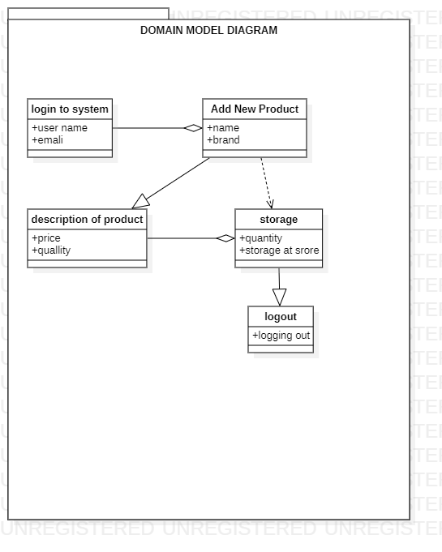**FULLY DRESSED USE CASE**

**ADD PRODUCT:**

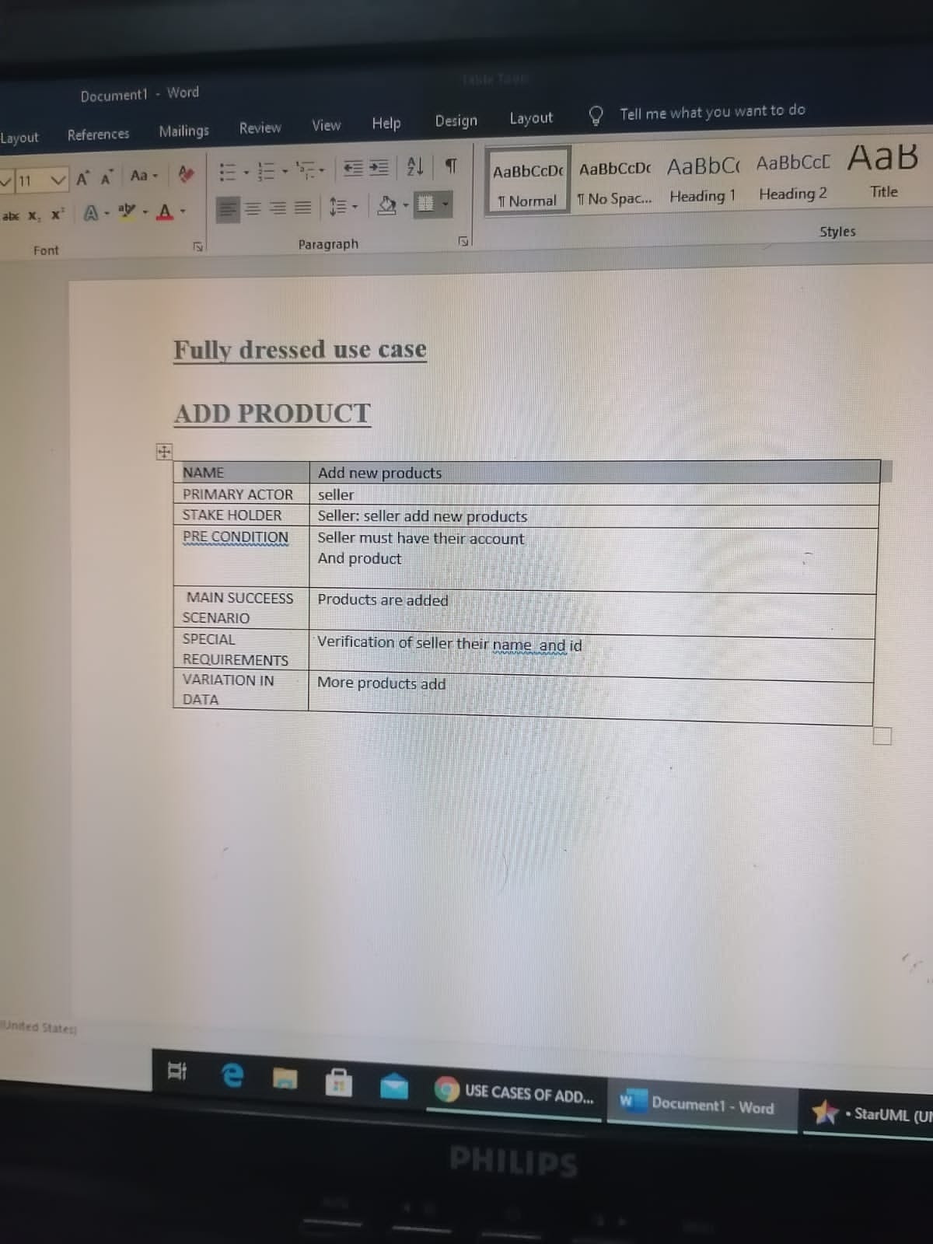

* ***Munawar Work:***

**Assigned Use case: Update Product**

**Fully dressed Use Case**

|  |  |
| --- | --- |
| **Name** | Sign up |
| **Level** | If new product is uploaded than seller will update it. |
| **Primary Actor** | Seller |
| **Stakeholder and Interests** | 1. Seller: Who wants to update the product |
| **Preconditions** | 1) Seller must logged in to system  2) product must should be uploaded |
| **Postconditions** | All necessary things of Product should be updated e.g description, image and price etc |
| **Main success scenario** | Admin will search for product , change its description , images and price etc , at the end system should display message , product has been updated successfully |
| **Extensions** | Condition: Update product   1. Checked description 2. Change price 3. Change image |
| **Changes in technology** | If new technical method came in market we will follow it if it’s more compatible |
| **Frequency of Occurrence** | Whenever new product is uploaded we will update it if required |

**Operation contract: Update Product**

|  |  |
| --- | --- |
| Operations | Seller inter into his seller account and search for product than will update product |
| Cross reference | Update product |
| Pre-Condition | Product should be uploaded |
| Post Condition | Product updated |
|  |  |

**System Sequence Diagram**

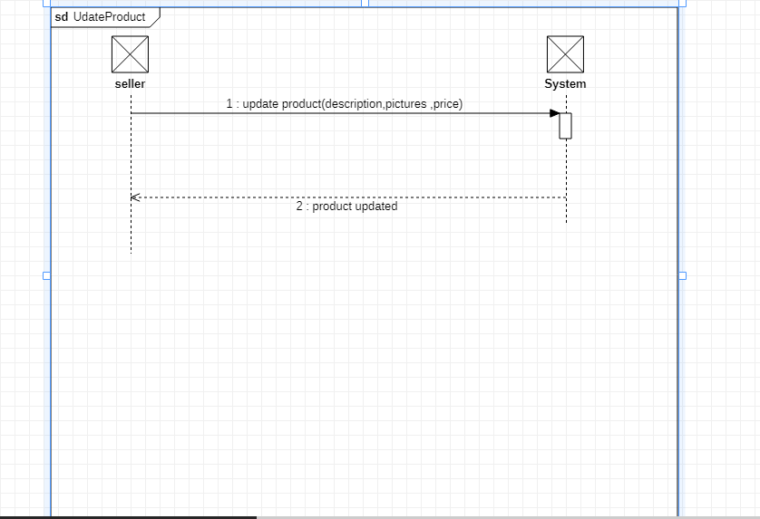

**DESCRIPTION**

Seller will log into his seller account by giving his Id/password. Than he will go at product category and will sure the product is uploaded. After checking the product he will update product’s description image and price etc.

After updating product the system will give the message that product has been updated successfully. Seller will use same procedure for every product to update it. Than seller can logout from the system.